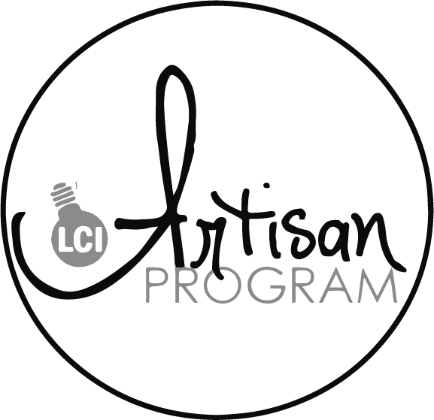
COURSE GUIDE 2024-2025
ARTISAN PROGRAM – COURSE OFFERINGS
Artisan Ceramics
Ceramics 15
The course begins with an exploration of the fundamental techniques and principles of ceramics. Students will learn the properties of different types of clay, methods of preparation, and various hand-building techniques, including pinch, coil, and slab construction. Emphasis will be placed on mastering basic forming techniques to create functional and sculptural pieces.

Ceramics 25 (Prerequisite Ceramics 15)
As students gain proficiency in hand-building, they will also be introduced to the pottery wheel in Ceramics 25. Through guided instruction and practice sessions, students will learn the art of wheel-throwing, focusing on centering, pulling, shaping, and trimming clay to create vessels such as bowls, cups, and vases. They will develop an understanding of the unique challenges and rewards of working with the pottery wheel, honing their skills through experimentation and practice.

Ceramics 35 – Prerequisite Ceramics 25
This course will encourage students to express themselves creatively and authentically through their ceramic work. Using skills from Ceramics 15 and 25 students will complete open-ended projects that explore themes such as identity, nature, memory, and social issues, using clay as a medium for self-expression and storytelling. They will develop their artistic voice, learning to communicate ideas through their creations.

Artisan Applied Graphic Design – Apparel and Promotion
Applied Graphic Design 15
The course begins by laying the foundation of graphic design principles and techniques. Students will explore typography, color theory, layout composition, and visual hierarchy, learning how to effectively communicate messages and evoke emotions through design. Emphasis will be placed on understanding the unique challenges and opportunities of designing for apparel and promotional products. Students will also explore various apparel types, including T-shirts, hoodies, hats, and bags, as well as promotional products such as mugs, and stickers.

Applied Graphic Design 25 (Prerequisite applied Graphic Design 15) – 2025/2026 Course
With proficiency in graphic design fundamentals, students will delve into the specific considerations of designing for wearables and merchandise. They will learn about different printing techniques, such as screen printing, heat transfer, and sublimation, and how these techniques influence design choices. Students will also explore various apparel types, including T-shirts, hoodies, hats, and bags, as well as promotional products such as mugs, and stickers.

Applied Graphic Design 35 (Prerequisite Applied Graphic Design 25) 2025/2026 Course
Through hands-on projects and real-world case studies, students will apply their knowledge to create a range of apparel and promotional designs. From designing logos and branding elements to developing artwork for specific products, students will learn to tailor their designs to suit different contexts, audiences, and marketing objectives. They will explore the role of graphic design in brand identity, product promotion, and visual storytelling, gaining insights into the strategic aspects of design decision-making.

Artisan Artistic Fabrication: Woodworking and Welding Fusion
Artistic Fabrication is a dynamic course that merges the timeless craftsmanship of carpentry with the industrial artistry of welding to unleash the creative potential of students. This hands-on class is designed for individuals who are passionate about both woodworking and metalworking and seek to merge these skills to create stunning, one-of-a-kind artistic designs.
Throughout the course, students will delve into the fundamentals of both carpentry and welding techniques, mastering essential skills such as measuring, cutting, shaping, joining, and finishing materials. Emphasizing safety protocols and best practices, students will gain confidence in working with various tools and equipment, including saws, drills, routers, welders, and grinders.
Artisan Woodworking and Welding 11 – Credits for Art 11
Artisan Woodworking and Welding 21 – Credits for Art 21
Artisan Woodworking and Welding 31 – Credits for Art 31
Please NOTE!
Highlighted courses do not need to be on registration for the 2024-2025 school year.
Full course descriptions on the following page

Artistic Fabrication: Carpentry and Welding (Art 11, 21, 31)
Course Description:
Artistic Fabrication is a dynamic course that merges the timeless craftsmanship of carpentry with the industrial artistry of welding to unleash the creative potential of students. This hands-on class is designed for individuals who are passionate about both woodworking and metalworking and seek to merge these skills to create stunning, one-of-a-kind artistic designs.

Throughout the course, students will delve into the fundamentals of both carpentry and welding techniques, mastering essential skills such as measuring, cutting, shaping, joining, and finishing materials. Emphasizing safety protocols and best practices, students will gain confidence in working with various tools and equipment, including saws, drills, routers, welders, and grinders.

The core of the course revolves around the synthesis of carpentry and welding techniques to produce artistic creations. Students will explore the fusion of wood and metal, learning how to seamlessly integrate these materials to craft functional and visually captivating pieces. From sculptural furniture to ornamental structures, students will experiment with different forms, textures, and finishes, pushing the boundaries of traditional craftsmanship.

In addition to technical skills, the course will nurture students' creativity and design sensibilities. Through brainstorming sessions, sketching, and prototyping, students will learn to translate their artistic visions into tangible works of art. They will explore various design principles, such as balance, proportion, rhythm, and harmony, to imbue their creations with aesthetic appeal and emotional resonance.

Furthermore, the course will foster critical thinking and problem-solving abilities by challenging students to overcome design constraints and technical obstacles. Through collaborative projects and peer feedback sessions, students will learn to communicate effectively, share ideas, and iterate on their designs, fostering a supportive and collaborative learning environment.

By the end of the course, students will emerge with a diverse portfolio of artistic creations that showcase their mastery of carpentry and welding techniques. Whether pursuing careers in woodworking, metalworking, sculpture, or design, graduates will possess the skills, confidence, and creativity to thrive in diverse artistic endeavors.

Course Title: Ceramics 15.25.35
Course Description:
Exploring Ceramics is an immersive and enriching course designed to introduce high school students to the versatile and expressive medium of ceramics. Through a combination of hands-on projects, demonstrations, and theoretical studies, students will embark on a journey to discover the artistry and craftsmanship inherent in working with clay.

The course begins with an exploration of the fundamental techniques and principles of ceramics. Students will learn the properties of different types of clay, methods of preparation, and various hand-building techniques, including pinch, coil, and slab construction. Emphasis will be placed on mastering basic forming techniques to create functional and sculptural pieces.

As students gain proficiency in hand-building, they will also be introduced to the pottery wheel. Through guided instruction and practice sessions, students will learn the art of wheel-throwing, focusing on centering, pulling, shaping, and trimming clay to create vessels such as bowls, cups, and vases. They will develop an understanding of the unique challenges and rewards of working with the pottery wheel, honing their skills through experimentation and practice.

In addition to technical skills, the course will delve into the aesthetic and conceptual aspects of ceramics. Students will explore principles of design, such as balance, proportion, texture, and color, to create visually compelling and conceptually rich pieces. They will draw inspiration from historical and contemporary ceramic artists, examining diverse styles, traditions, and cultural influences.

Furthermore, the course will encourage students to express themselves creatively and authentically through their ceramic work. Through guided prompts and open-ended projects, students will explore themes such as identity, nature, memory, and social issues, using clay as a medium for self-expression and storytelling. They will develop their artistic voice, learning to communicate ideas and emotions through their creations.

Throughout the course, students will also learn about the technical aspects of ceramics, including clay preparation, glazing techniques, kiln firing, and studio maintenance. They will gain an understanding of the chemical and physical processes involved in ceramic production, as well as the importance of safety and environmental stewardship in the studio.

Course Title: Applied Graphic Design - Apparel and Product Design 15.25.35
Course Description:
Applied Graphic Design: Apparel and Promotional Products is a dynamic course that immerses students in the exciting world of designing for wearables and merchandise. Through a blend of creative exploration, technical skill development, and industry insight, students will learn to conceptualize and execute compelling designs that resonate with target audiences and drive engagement.

The course begins by laying the foundation of graphic design principles and techniques. Students will explore typography, color theory, layout composition, and visual hierarchy, learning how to effectively communicate messages and evoke emotions through design. Emphasis will be placed on understanding the unique challenges and opportunities of designing for apparel and promotional products.

As students gain proficiency in graphic design fundamentals, they will delve into the specific considerations of designing for wearables and merchandise. They will learn about different printing techniques, such as screen printing, heat transfer, and sublimation, and how these techniques influence design choices. Students will also explore various apparel types, including T-shirts, hoodies, hats, and bags, as well as promotional products such as mugs, and stickers.

Through hands-on projects and real-world case studies, students will apply their knowledge to create a range of apparel and promotional designs. From designing logos and branding elements to developing artwork for specific products, students will learn to tailor their designs to suit different contexts, audiences, and marketing objectives. They will explore the role of graphic design in brand identity, product promotion, and visual storytelling, gaining insights into the strategic aspects of design decision-making.

By the end of the course, students will have developed a robust portfolio of apparel and promotional designs that showcase their creativity, technical skills, and understanding of design strategy. Whether pursuing careers in graphic design, marketing, or entrepreneurship, students will emerge from the course equipped with the tools and knowledge to thrive in the dynamic field of applied graphic design.

