|  |  |  |  |  |  |
| --- | --- | --- | --- | --- | --- |
|  |  | |  | | --- | | LCI  Career Corner | | September 2019 | |  | |
|  |  |  |
|  |  | In This Issue |

**LCI’s Career Practitioner Overview**

Hello, Let me introduce myself I am new to L.C.I. this year and I will be filling in for the remainder of a maternity leave, my name is Amanda McMahon and I can be reached through e-mail at [Amanda.mcmahon@lethsd.ab.ca](mailto:Amanda.mcmahon@lethsd.ab.ca) 403-328-9606 ext. 24109

My role within the school is to advise students in the area of career and post-secondary opportunities and increase awareness so students can make informed decisions about life after high school. This is accomplished through assessing goals, using career exploration tools, suggesting research, recommending high school courses, connecting you with school based and offsite activities and linking you to post-secondary institutions.

My office is E215 and is located in the Wellness Centre, you can meet with me Monday to Thursday between 7:45 a.m. and 3:30 pm and Fridays from 7:45am – 12:30pm. I am out of the office Wednesday’s. I am looking forward to meeting and working with you all and I am excited for a great new year.

Career Practitioner Overview………………… pg 1

Upcoming Events………………………………… pg 2

Resources……………………………………………pg 3



It matters not what someone is born, but what they grow to be”

J.K. Rowling

September - Areas of Focus

* Participate in and Check out the Information Booths in Main Foyer at LCI
* Post Secondary Open Houses
* Information session on Introduction to Ironworking
* Post-Secondary Fair @ Chinook High School

**Off-Campus Education**



**Do you know about Work Experience? To be involled in this program you MUST have completed HCS 3000-Workplace Saftey Systems. If you are unsure or have questions please come on in and see me I am here to help you!**

Registered Apprenticeship Program (RAP) and Work Experience Program (WE)

Andrew Krul – Off Campus Coordinator [andrew.krul@lethsd.ab.ca](mailto:andrew.krul@lethsd.ab.ca)

(403) 894-0375

Jacquie Lowe –

Admin Support

[Jacquie.lowe@lethsd.ab.ca](mailto:Jacquie.lowe@lethsd.ab.ca)

(403) 394-4621

Work Experience Students can earn valuable high school credits for the skills developed in part time jobs and volunteer positions. Work Experience is good to have on a resume and helps you gain high school credits towards your diploma.

The Registered Apprenticeship Program (RAP) is an opportunity for students to get a head start in a career to pursue full time when they graduate. Students learn to work, make themselves marketable, and apply classroom learning. Up to 40 credits may be earned and students are paid. See www.tradesecrets.gov.ab.ca for a complete description of all 50 plus trades.

**Upcoming Events**

**Job Shadow Information Booth – Sept 30,2019**

Lunch (LCI Main Foyer) at LUNCH: 11:49-12:24

Come and ask how a Job Shadow can help you learn more about a career that interests you.

Individual Placements open to 11, and 12

Group Placements open to Grades 10, 11, and 12

**Please Bring Completed forms back to Amanda in the wellness centre.**

**Introduction to Ironworking Information Night- October 16, 2019**

Location: Training Centre 2801-2nd Ave North, Lethbridge

Come and find out what this program is all about, two sessions will be available 5:00-6:30 p.m. or 7:00-8:30 p.m.

**Regional Post-Secondary Fair – Oct 23,2019**

This year it will take place at **Chinook High School: 259 Britannia Blvd.West**

More Information to come as soon as it is available! Please check back!

**SAIT Information Booth – Oct. 29, 2019**

LCI Main Foyer 11:49 am – 12:24pm (Lunch) Come and talk to a recruiter to learn more about what SAIT has to offer



**Summer Work Experience Hours Due - Sept 27,2019**

If you are signed up with Work Experience Please Hand your summer work experience hours into Jacquie Lowe as soon as possible in the OffCampus Education office located in **room B113**. Don’t miss out on Credits that you have earned!

**Scholarships**

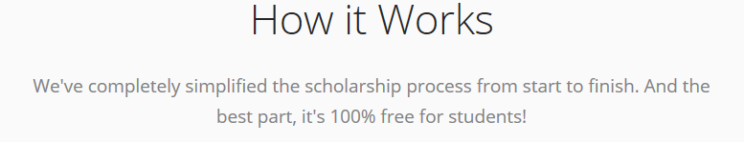

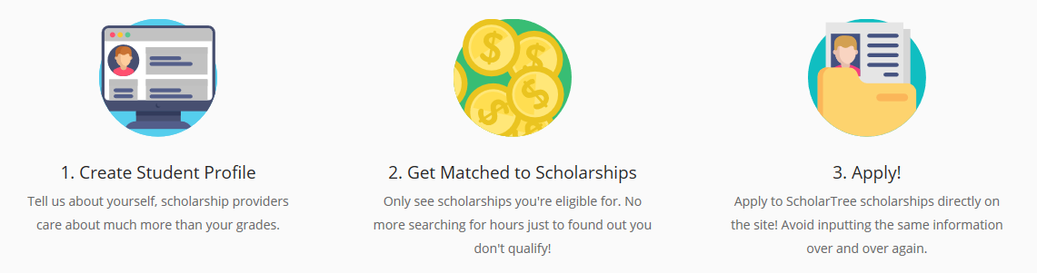

Set Up an Account Today!

**Scholarship Websites**

* [www.alis.gov.ab.ca](http://www.alis.gov.ab.ca)
* [www.aucc.ca](http://www.aucc.ca)
* [www.studentawards.com](http://www.studentawards.com)
* [www.scholarshipscanada.com](http://www.scholarshipscanada.com/)
* [www.canlearn.ca](http://www.canlearn.ca)
* [www.uleth.ca](http://www.uleth.ca)(search scholarships)
* [www.lethbridgecollege.ca](http://www.lethbridgecollege.ca) (search scholarships)
* <https://scholartree.ca/>

Amanda McMahon

[amanda.mcmahon@lethsd.ab.ca](mailto:amanda.mcmahon@lethsd.ab.ca)

Career Practitioner

Lethbridge Collegiate Institute

Lethbridge, Alberta T1J 0W4

403-328-9606 ext. 24109

**Resources**



**This is a GREAT one stop shop for exploring interests, discovering career pathways, labour market information, Post-Secondary Information and much much more! Be sure to check it out.**

**How to login:**

Go to [www.myblueprint.ca](http://schulichleaders.com/about-scholarship)

New user –

How to login:

1. Go to [www.myblueprint.ca/lethbridge](http://www.myblueprint.ca/lethbridge)

2. Click “Sign up” on the top of the page

3. Choose your school

4. Create an account using your school email

5. Ex. [Bob.smith20@lethsd.ab.ca](mailto:Bob.smith20@lethsd.ab.ca)

Existing user – enter email and password

If you have forgotten your password enter your email address and click on the “forgot your password” prompt

You can watch the online tutorials in myblueprint to learn more about it, or see Career Paractitioner Amanda McMahon for one to one support.

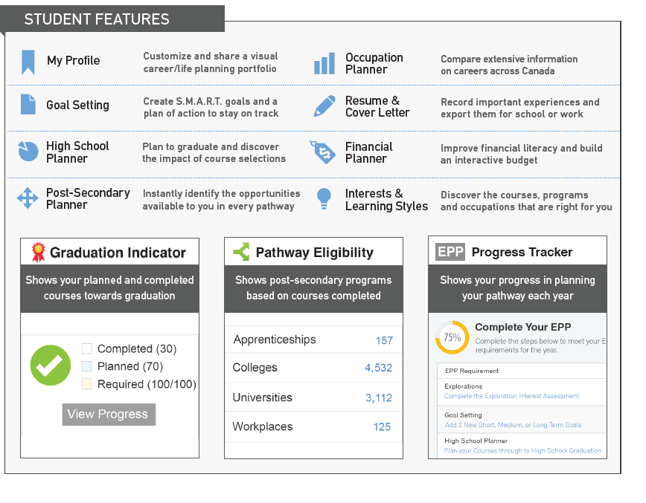

Top of Form

Bottom of Form

Let’s Connect! I would love to meet with you don’t be a stranger.